STATE OF CALIFORNIA – NATURAL RESOURCES AGENCY EDMUND G. BROWN JR., Governor
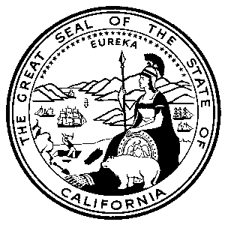
CALIFORNIA ENERGY COMMISSION
DIVISION OF FINANCIAL SERVICES
CONTRACTS, GRANTS & LOANS
1516 NINTH STREET, MS-18
SACRAMENTO, CA 95814-5512
(916) 654-4381
www.energy.ca.gov

Karen Schooler
SLAC National Accelerator Laboratory
2575 Sand Hill Road
Menlo Park, CA 94025

Re: GRANT AWARD NUMBER: EPC-17-047
OpenFIDO: Open-source Framework for Integrated Data Operations
PROCEDURE FOR EXECUTING AGREEMENT
- Enclosed are two copies of the Grant documents, please have each CEC 146 signed by the authorized person identified in your resolution. Return both signed copies to me at the address below.
- This grant award agreement is not binding on either party until fully and properly executed by the authorized state officials. A copy of the agreement will be sent to you when it has been executed by the State.
FUND AVAILABILITY
Funds in this award have a limited period in which they must be expended. All recipient expenditures must occur prior to the end of the term of this agreement.
EFFECTIVE DATE
The start date is based upon an allocation of two weeks for your review. The Effective Date of this Agreement, however, is the date the California Energy Commission signs the Agreement. The California Energy Commission shall be the last party to sign. No work is authorized, nor shall any work begin, until on or after the effective date.
PROJECT ASSISTANCE
There are two offices at the Commission with staff to assist you with your grant award. Contact me at (916) 651-0588 or andrea.hoppe@energy.ca.gov for administrative questions and the Commission Agreement Manager listed in Exhibit F for technical questions.
Sincerely,

Andrea Hoppe
Commission Agreement Officer
California Energy Commission
1516 Ninth Street, MS-18
Sacramento, CA 95814
Enclosures
cc: Steve Ghadiri, Commission Agreement Manager, MS-43
File

